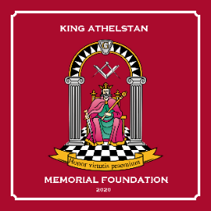
THE MASONIC ORDER OF ATHELSTAN

KING ATHELSTAN
MEMORIAL FOUNDATION

ORDER FORM
MEMORIAL FOUNDATION LAPEL PINS (as per logo)
All proceeds will go to the Foundation
Please send your cheque made payable to:
“King Athelstan Memorial Foundation”
or
If paying by BACS
HSBC Bank Sort Code: 40-19-20
Account Name: “King Athelstan Memorial Foundation”
Account Number: 64174003
Reference: your Surname + Court number +PIN
And advise Lionel by email at lionelbmee@gmail.com

Pins will be despatched post free
----------------------------------------------------------
(Please detach above)

Your Full Name: __________________________________________________________
Address: _________________________________________________________________
__________________________________________Post Code______________________
Telephone: __________________________e-mail _______________________________
I wish to order: -
_________Lapel Pins@ £5 per Pin = £ __________

I enclose my cheque for £___________ (NO postage charges required)
Payable to “King Athelstan Memorial Foundation”
OR
I have paid the sum of £__________by BACS on _____________(date)

Account Name: “King Athelstan Memorial Foundation”
HSBC Bank Sort Code: 40-19-20 - Account Number: 64174003

If paying by cheque, please send this completed Order Form + cheque to:

Lionel Mee, 4 The Willows, Lightwater, Surrey, GU18 5PJ
If paying by BACS please e-mail your Order Form with contact details to:
pgm@athelstansussex.org.uk

